EMBEDDINGS
What Are Embeddings?
Embeddings are dense numerical vector representations of:
- users
- products
- ads
- queries
- sessions
They capture semantic meaning.
Example:
Nike Shoes → [0.12, -0.98, 0.44, ...]
Adidas Shoes → [0.10, -0.95, 0.41, ...]
Nearby vectors = semantically similar.

Why Do Embeddings Exist?
Traditional categorical encoding:
- sparse
- huge dimensionality
- poor semantic understanding
Embeddings solve:
- semantic similarity
- scalability
- personalization
- retrieval

Theory
Core idea:
- Learn latent representation spaces.
Similarity is often computed using cosine similarity.
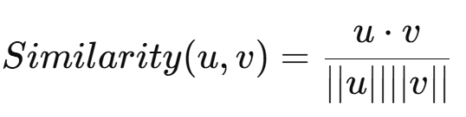

Role In Architecture
Embeddings power:
- candidate retrieval
- ANN search
- personalization
- semantic matching
Without embeddings: modern recommender systems do not scale.

Hands-On POC
POC 1
Movie recommendation using:
- user embeddings
- movie embeddings
- cosine similarity
Use:
- MovieLens dataset
- TensorFlow/PyTorch

Best Practices
- Normalize embeddings
- Retrain periodically
- Separate offline/online embeddings
- Use dimensionality carefully

Trade-Offs
Small Embeddings | Large Embeddings
Faster | More expressive
Lower memory | Better accuracy
Less semantic richness | Expensive

Failure Modes
- Embedding drift
- Popularity bias
- Cold start
- Vector collapse

Principal-Level Thinking
Questions:
- How often to retrain embeddings?
- Can embeddings be updated online?
- Memory vs accuracy tradeoff?
- How to serve billions of vectors?

